COMP 314

ASSIGNMENT 2

GROUP AD

**CONTENTS PAGE**

1. ROLES OF EACH PERSON
2. SCREENSHOT OF THE CODE
3. BIBLIOGRAPHY

**N.B PLEASE CHANGE FILE PATH**

1. **ROLES OF EACH PERSON**

Team Ad compromises of 4 students from the comp314 class each tasked with various parts of the assignment to complete in the java programming language:

* Jirah Moodley and Sabelo Prosperous Zulu which were tasked for GUI design and test and refining the program. They went for a simple and intuitive design with multiple labels for ease of use for the end-user.
* Darisha Pillay and Olothando Gwiji who were tasked for the development of the major body of the program. They designed the code very ideally and added error handling features.

1. **SCREENSHOT OF THE CODE**

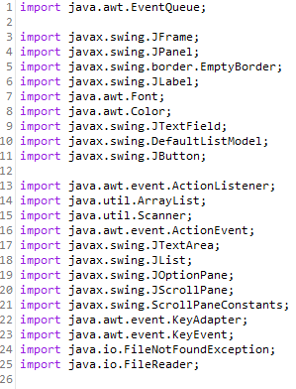

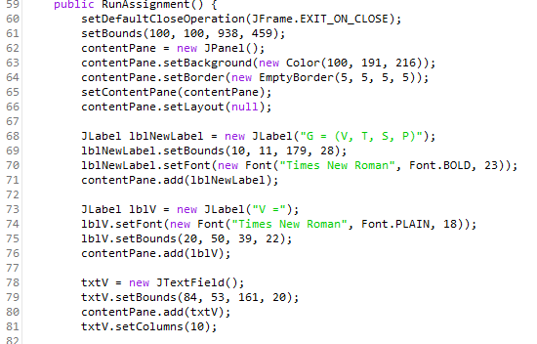

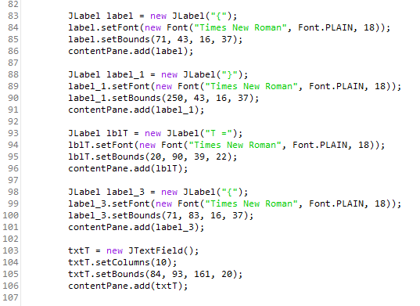

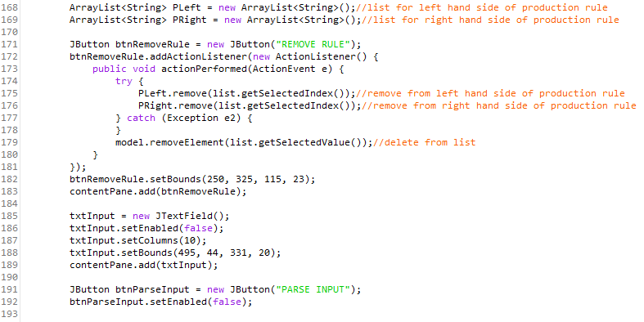

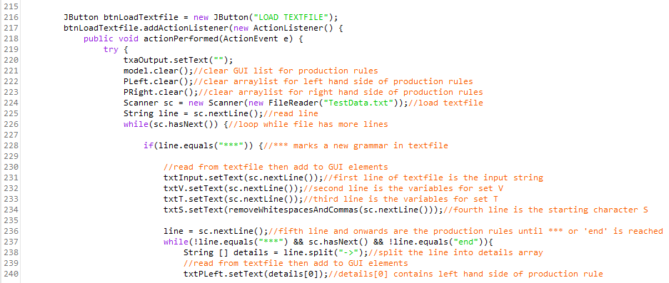

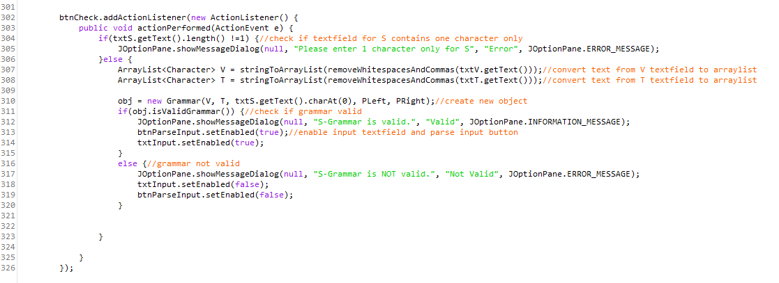

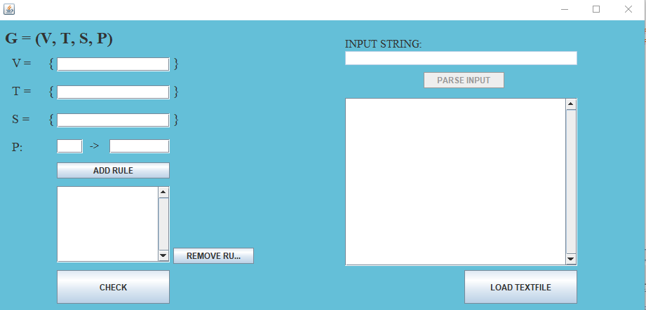

The code has many more features not displayed above but is utilised in and throughout the project. The GUI is simple but gets the job done. Comments are used all over and where ever possible to make documenting the code easy and allows for ease of use and development for each member of the team. Our team used GitHub to work and develop the assignment and gave us a central point of access to the code/assignment.

1. **BIBLIOGRAPHY**

Our team used various resources for the development of the assignment listed below:

* <https://stackoverflow.com/>
* <https://www.geeksforgeeks.org/>
* <https://github.com/>
* <https://www.youtube.com/>
* <https://w3schools.com/>
* <https://google.com/>